“I wouldn’t take nothing for my journey…”
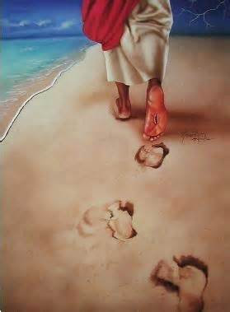

You are invited
to join us for
a
Homecoming Celebration

Come and be a part of our
festive worship , renew old acquaintances, celebrate family
and fellowship with God’s ministries of Meade.

WHEN: Sunday, October 26, 2014 - 9:45am
WHERE: Meade Memorial Episcopal Church
322 North Alfred Street – Alexandria, VA 22314
703 549-1334
The Very Rev. Collins Asonye, Rector

