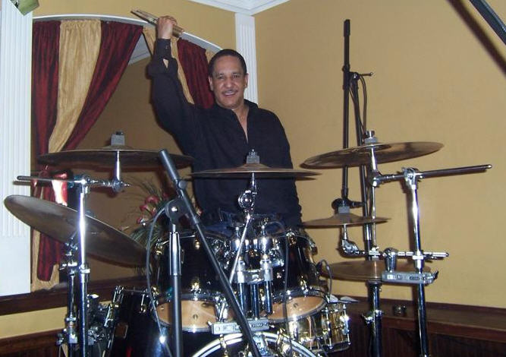

JAZZ AT MEADE
featuring Kenny Sanders and Friends

Kenny Sanders, a native of Cleveland, Ohio, comes from an environment saturated with music. It was weaved into his life at a very young age. He learned to read music in elementary school, and by the age of thirteen he was performing professionally in the Cleveland night clubs. Mr. Sanders’ style of music is inclusive of various genres, including gospel, R&B, classical and contemporary jazz, and alternative and classic rock. He has performed or been associated with renowned artists such as the Coasters, Drifters, Marvelettes, Platters, O’Jays, Lavert, Roy Ayers, Nick Corleone, Steve Oliver, and Brian Culbertson. Join us for an afternoon of engaging melodies.

Meade Memorial Episcopal Church
322 N. Alfred St
Alexandria, VA 22314
Aug 21, 2011 4 pm
Donation: $15.00
703-549-1334

Light refreshments will be served.

Parking is available in the church’s lot and on the street.
http://www.meadechurch.org meadememchurch@hotmail.com

