

**Saturday, May 20, 2017**

**1:30 – 4:30 p.m.**

**Meade Memorial Episcopal Church**

322 N. Alfred St.

Alexandria , VA 22314

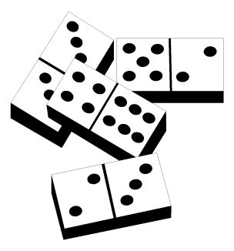 Board Games

Card Games Refreshments

Door Prizes



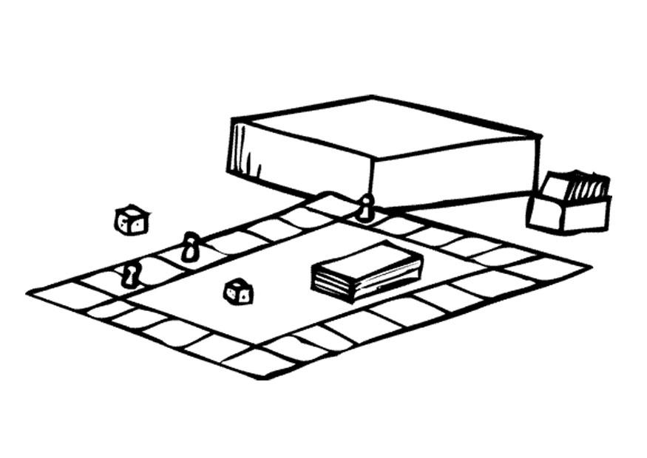

Donation - $10

Call the church office (703-549-1334)

for more information